3.Write a python program to solve water jug problem

Aim:
To write a Python program to solve the Water Jug Problem.

Objectives:
The objective of this program is to solve the Water Jug Problem by measuring the required amount of water using two jugs of different capacities through filling, emptying, and pouring operations.

Algorithm:
1. Start.
2. Initialize both jugs as empty.
3. Fill the first jug completely.
4. Pour water from the first jug into the second jug until the second jug is full.
5. Empty the second jug.
6. Pour the remaining water from the first jug into the second jug.
7. Fill the first jug again.
8. Pour water into the second jug until the required amount is left in the first jug.
9. Display the result.
10. Stop.
Flow chart:
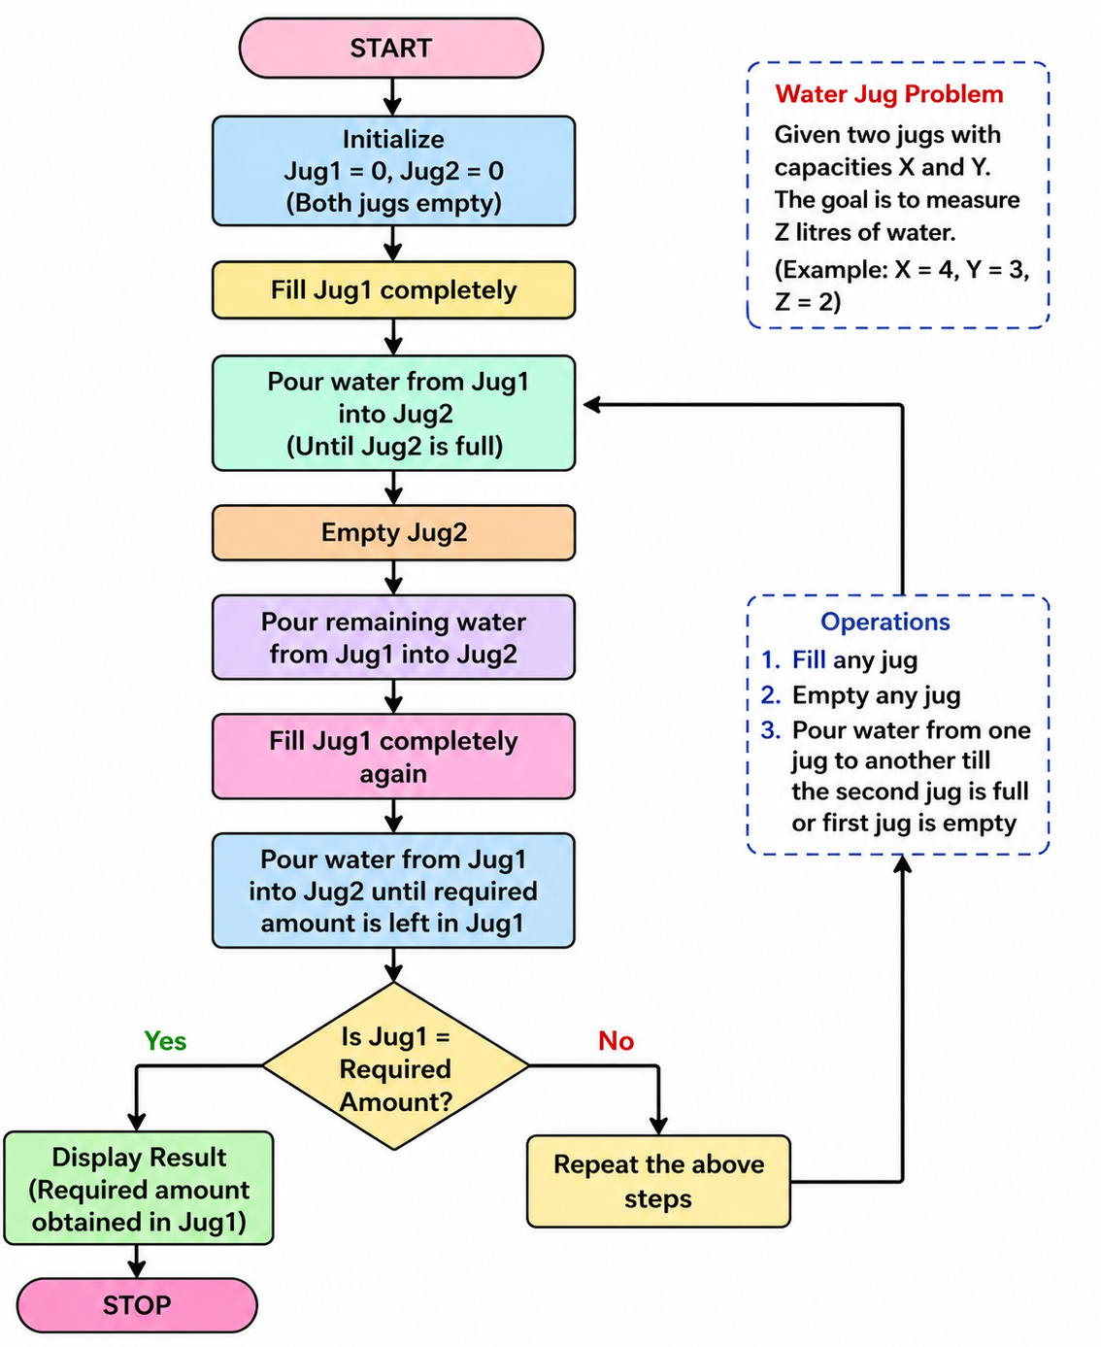

Source Code:
# Water Jug Problem

jug1 = 0
jug2 = 0

while jug1 != 2:
if jug1 == 0:
jug1 = 4
print(jug1, jug2)

elif jug2 == 3:
jug2 = 0
print(jug1, jug2)

else:
transfer = min(jug1, 3 - jug2)
jug1 -= transfer
jug2 += transfer
print(jug1, jug2)

print("Goal Achieved: 2 Litres in Jug1")

Result:
The program was executed successfully, and the required quantity of water was measured using the two jugs. The goal state was achieved successfully.

Output:

